PROJECT REPORT

1. INTRODUCTION:
   1. OVERVIEW:

The project in the zoho books for Urban aura interiors involves the creation of financial statement which includes income statement, balance sheet& cash flow statement these statement are essential to assess the financial health of the company .

* 1. PURPOSE:

By creating a financial statement I the zoho books we can gain deep understanding of our company’s financial standing and make strategic adjustments to improve your performance and it helps in identify trends .

1. PROBLEM DEFINITION & DESIGN THINKING:
   1. EMPHATHY MAP :

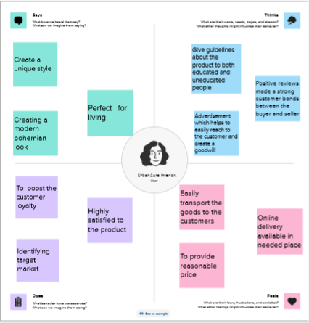

2.2 IDEATION & BRAINSTROMING MAP:

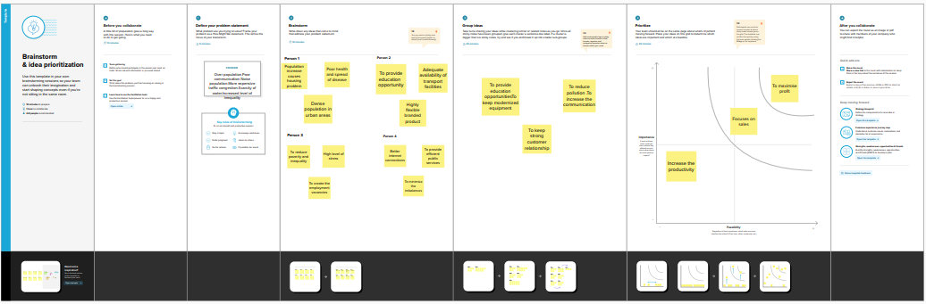

1. **RESULT:**

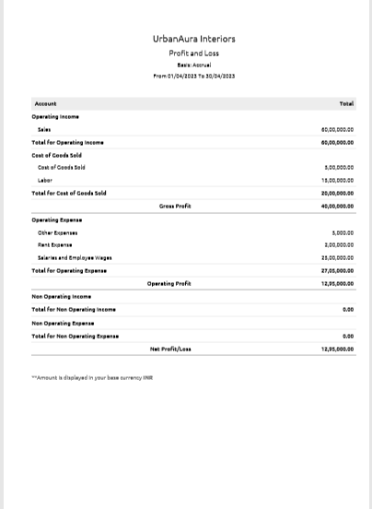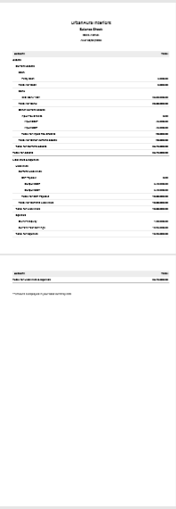

1. **ADVANTAGES & DISADVANTAGES :**
   1. ADVANTAGES :

* Rich feature set
* Easy to use accounting features
* Flexible pricing
  1. Disadvantages
* Lack of integration .
* Dissuad high volume in monthly transactions and users .
* Accounts payable limitations .

1. APPLICATIONS:

* Customised transactions
* Manage multiple projects easily
* Track and simplify

1. CONCLUSION

* zoho books is easy to understand and its configuration is quick and easy
* The automation of the system is great and we save the lot of time

7.FUTURE SCOPE

* Zoho books controls the type of resources that the client application can access
* It takes care the accounting needs of the business